Study of Restaurant business in Town of Barnet in England

Wang

11th March 2021

1. Introduction
   1. Background

In Catering Industry, location of restaurant is a critical successful factor, especially when target customers are students, teachers and other education partitioners. It is advantageous to locate the restaurants at place where it is closed to your customers such that they can easily access to your restaurant. On the contrary, if there’s a lot of competitors or close substitutes, potential customers might compare the prices, quality, styles and etc among you and your competitors.

* 1. Problem

Locational data like location of schools and closed substitute become important factors to be taken into considerations. This project aims to select location of restaurant, whether it should be located and target at special cluster of schools.

1. Data acquisition and cleaning
   1. Data source

In the web, there’s paid information of all school geographic locations but free information is quite limited. However, local govt offers the free information of school with post codes (ie.

<https://www.gov.uk/government/publications/schools-in-england>) which allows us to map with latitude and longitude information based on post codes. (<https://www.freemaptools.com/download/>)

On top, we retrieve the geographic data of venues via foursquare API to access the closeby venues, esp the competitors.

2.2 Data Cleaning

Data downloaded and scrapped into table in python. However, we observed some information has missing latitude and longitude information or schools do not have complete information. As such, those NA data records are removed for analysis purpose.

* 1. Feature selection

Among all schools, we have selected the data set where school are located in Town of Barnet and it includes all kind of schools there, including primary school, secondary school, aided schools, grammer schools. We’d assume that the catering requirements and demand are comparable among different types of schools.

Meanwhile, we dropped the information like Locality, local authority (e.g. city council of London), etc which are irrelevant to our analysis.

**3. Exploratory Data Analysis**

3.1 Visualize the schools at Barnet

3.2 Analyze on the top Nth venues nearby the schools

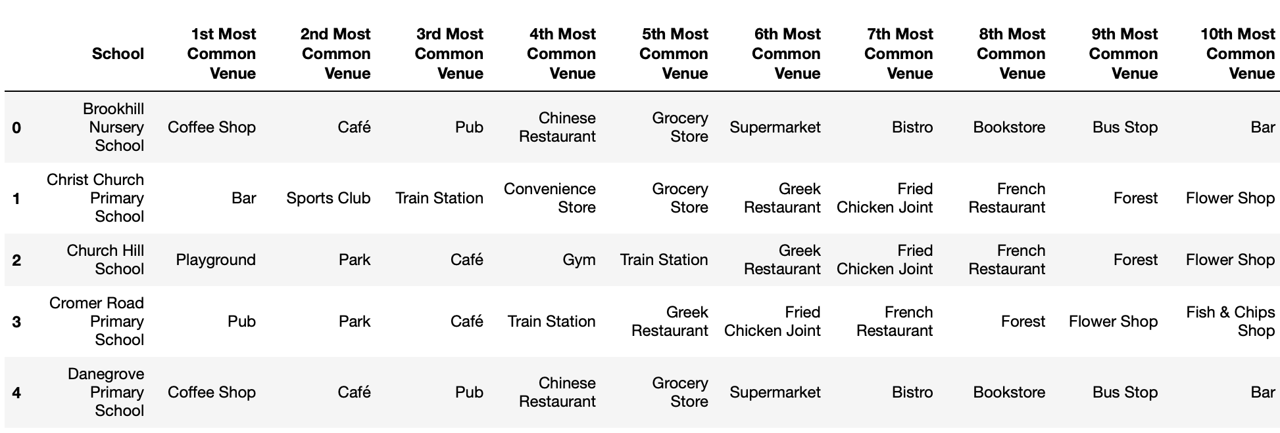

3.3 Clustering of venues by type of categories (e.g. cafe, restaurants, sport center, etc)

1. **Conclusions**

In this study**, it can be found that Cluster 0 has much less restaurants and Cluster 1 has much more restaurants. It means if restaurant business is setup at Cluster 1, it can definitely face less competition and most of school students would be served by this restaurant business. Due to proximity of schools, it is more competitive in terms of ease to access the restaurant and transport lead time is limited.**

**Meanwhile, it is also found that Cluster 1 is more widely spread over the Town of Barnet and it means that it is hard to serve most of schools in the town as there's no centroid that allow ease of access without close substitute / competitions.**